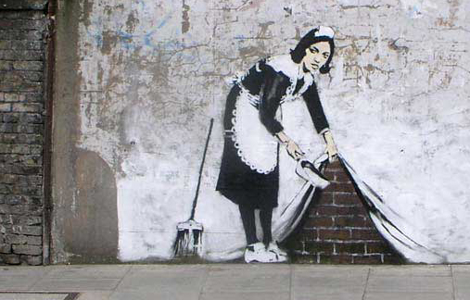 BANKSY questionnaire
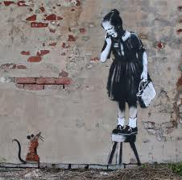

Name :
birth :
nationality :
occupations :
artistic technique :
messages / movement :
subjects:
examples of famous works : (titles)
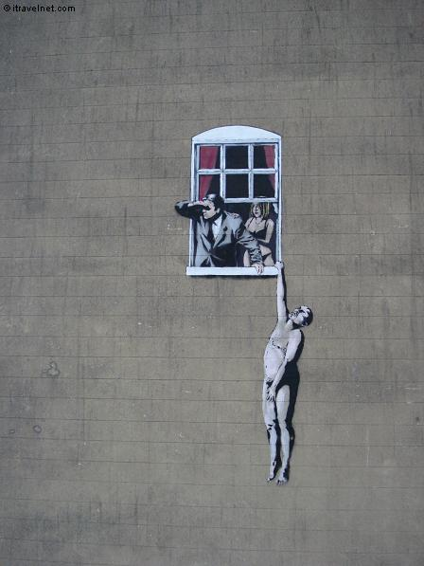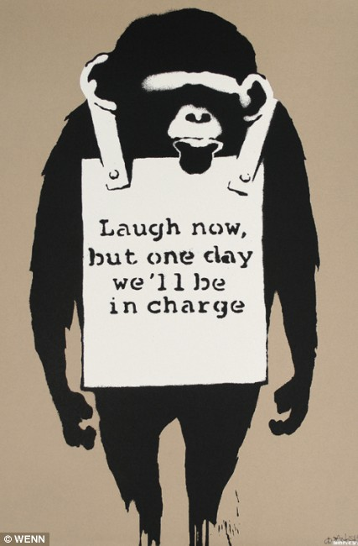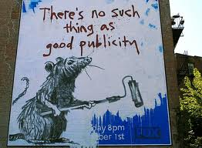
Banksy-identity controversy: How many times has he been filmed or photographed?
speculated name:
What does he do when he gains an award?
why? → he continues with his notorious anonymous status
STENCILS: they are traditionnaly hand drawn or printed onto sheets or card before being cut out by hand (in French = …………………….).
Why did Banksy choose this technique?
MISCELLANEOUS :
* in 2003, at the « Turf War » exhibition, what did he paint on ?
* What did he do to British £10 notes? He substituted the picture of the …………. ‘s head with ………….. ‘s + he changed the text “Bank of England” to “…………………………….”
*How did he represent Samuel L.Jackson and John Travolta in a scene of Pulp Fiction? They were holding ………………. Instead of guns ; later he painted them in ………………. Costumes , holding real …………. .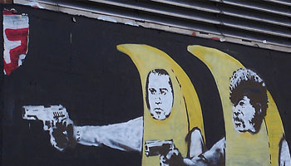
*What did h commemorate in August 2008 in New Orleans?
* What did he paint in the penguin enclosure of the London zoo? “WE ……………….’
* In 2006, whose album did he replace with his own cover and remixes?

ONE NATION UNDER CCTV 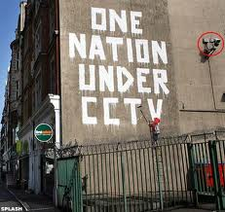
what?
when?
where?
size?
Decision of the Westminster City Council:
Why?
when did they have it done?

